**EXP NO 8** Create a simple cloud web application for student counselling system using any Cloud Service Provider to demonstrate SaaS with the fields of student name, age, address, phone, subjects studied, Year of passing, percentage of marks, domain interest, etc.

**PROCEDURE**

**STEP 1** GO TO ZOHO.COM

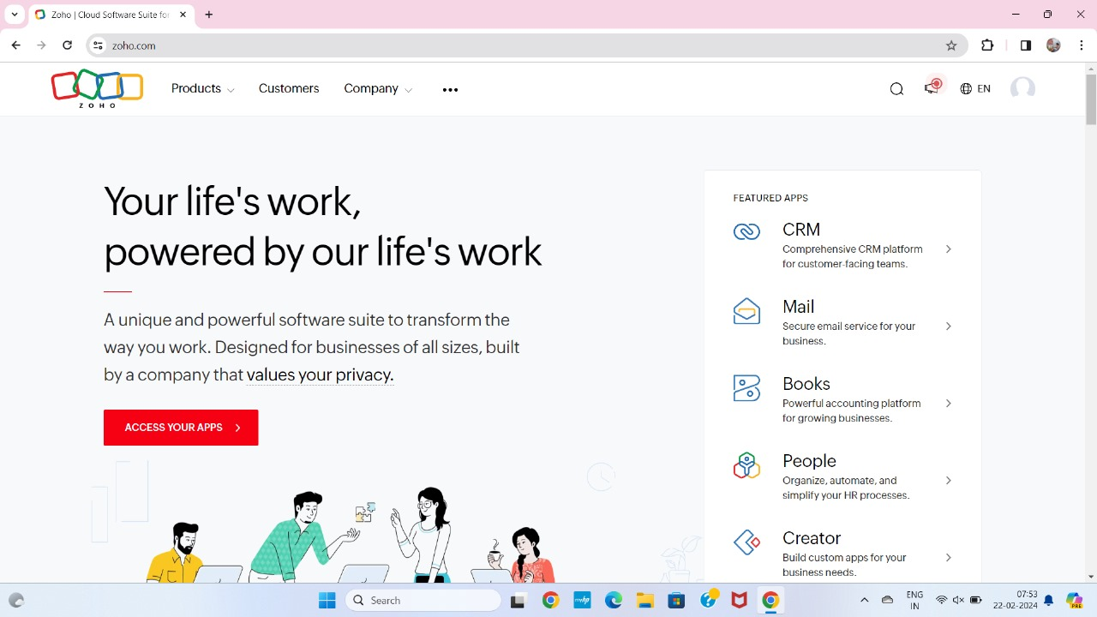

**STEP2** LOGIN TO THE ZOHO.COM

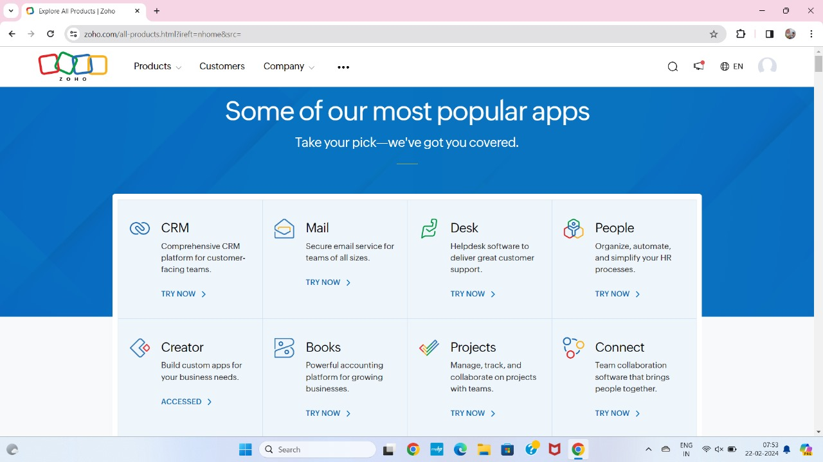

**STEP 3** SELECT A CREATE FROM SCRATCH

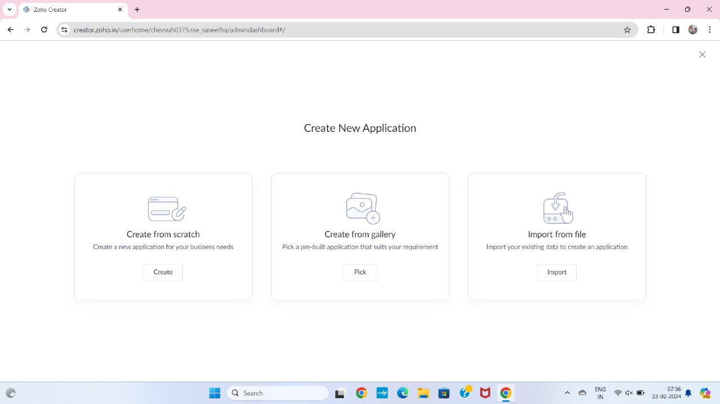

**STEP 4** SELECT APPLICATION NAME AS STUDENT COUNSELLING SYSTEM

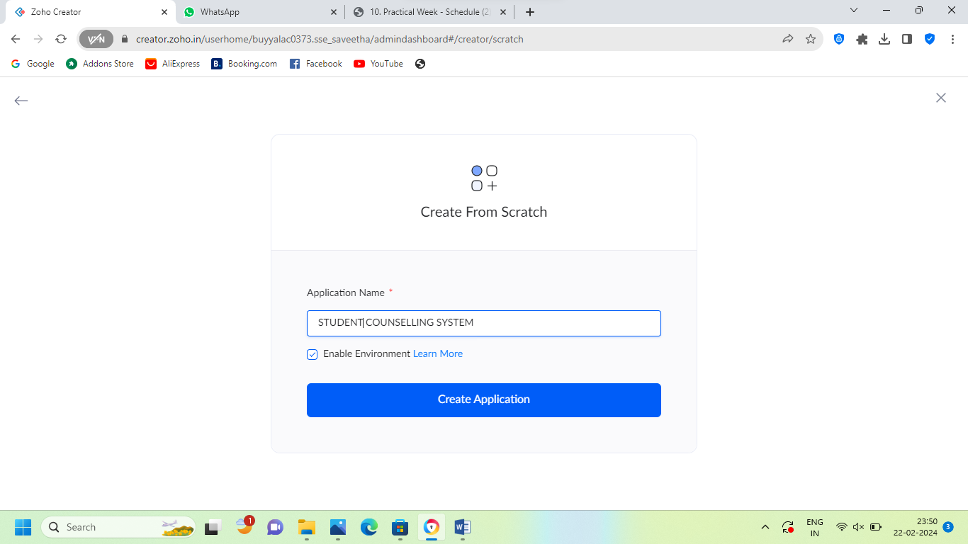

**STEP 5** CREATE A NEW FORM

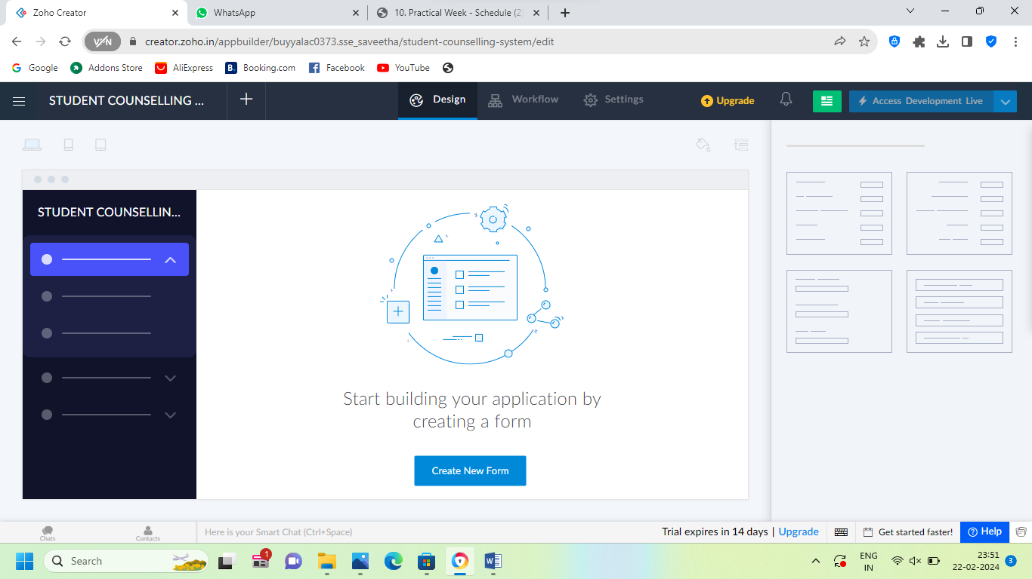

**STEP 6** SELECT BASIC FIELD FROM GIVEN BELOW AND DEVELOP APPLICATION

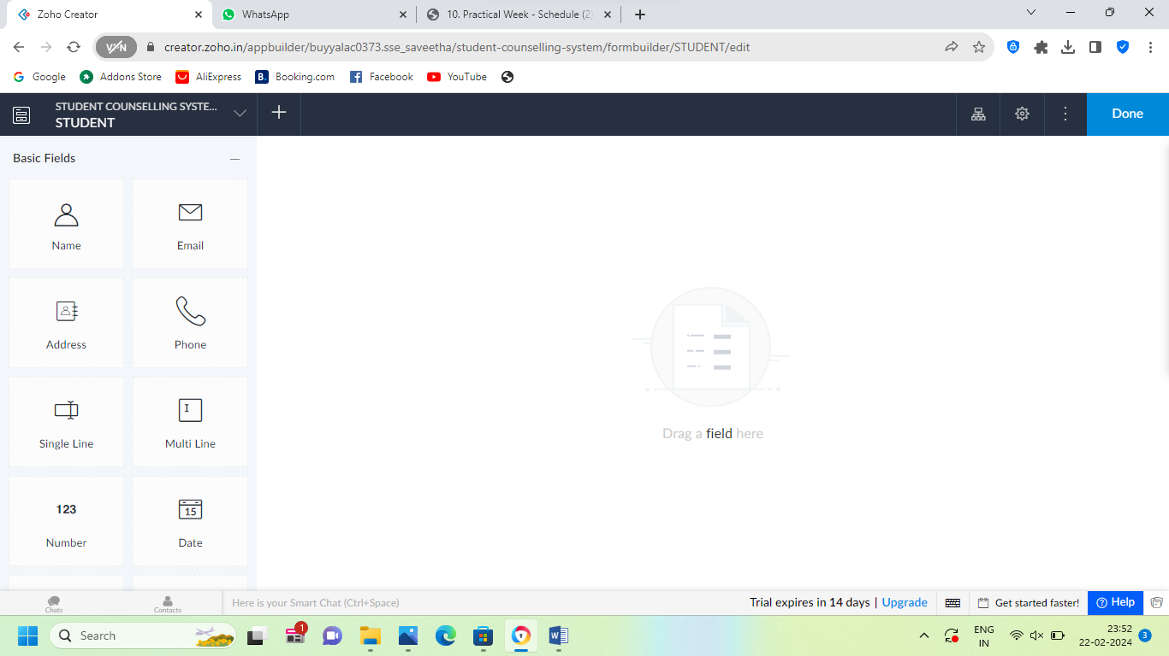

**STEP 7** THE SOFTWARE HASE BEEN CREATED STUDENT

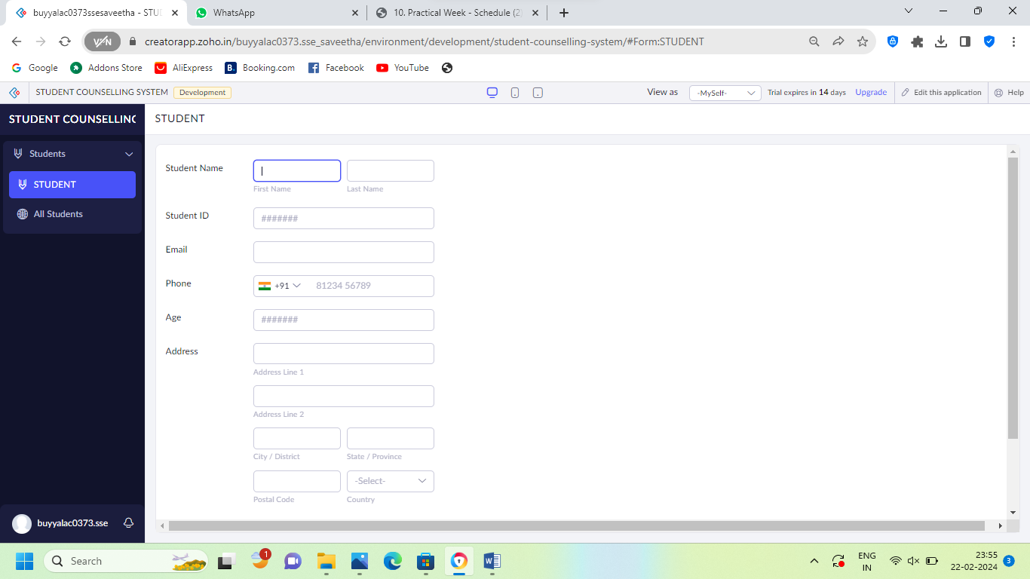

**STEP 8** THE SOFTWARE HASE BEEN CREATED STUDENT COLLAGING

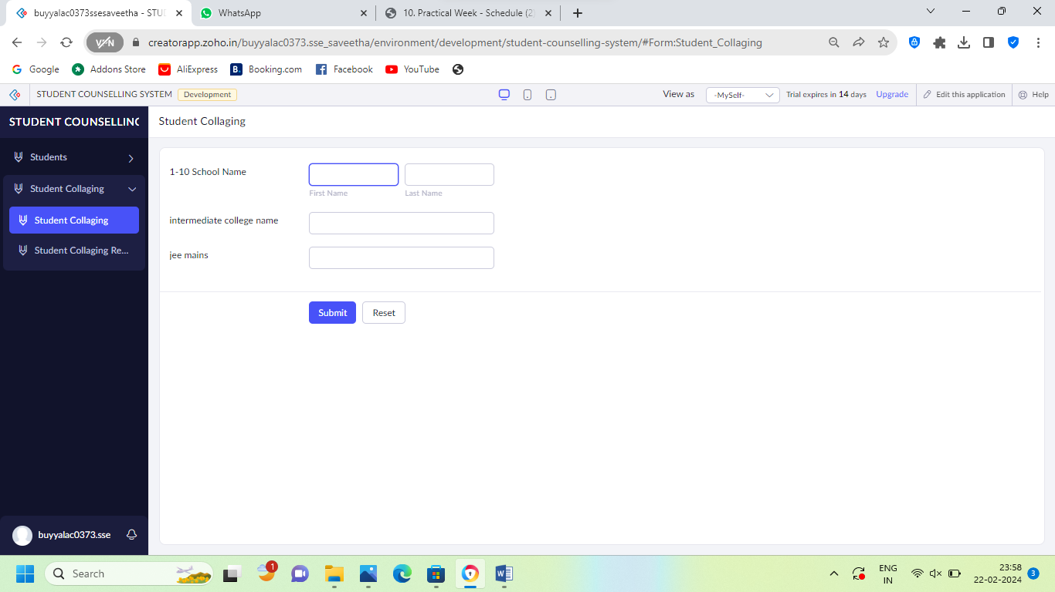

**STEP 9** THE SOFTWARE HASE BEEN CREATED HOBBIES

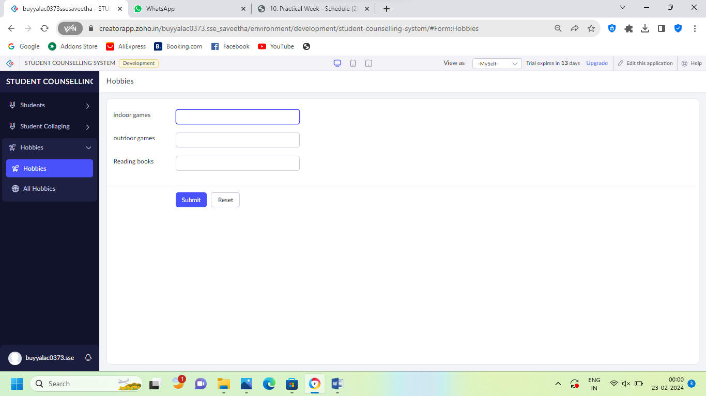

**STEP 10** THE SOFTWARE HASE BEEN CREATED

